
Name : Ch Mubashir.
SAP : 56892.
Course : Data Visualization (BS-DS-6-1).
Instructor : Uzair Rasheed.

**LAB TASK 02**
Data Visualization in Excel

1. Introduction
This lab focuses on reporting and visualizing insights from the Titanic dataset using Microsoft Excel. Different Excel features such as sorting, filtering, conditional formatting, charts, and pivot tables are used to analyze passenger survival patterns.

2. LAB OBJECTIVES
The objectives of this lab are:
- To explore a real-world dataset
- To perform sorting and filtering
- To apply conditional formatting
- To create different charts
- To analyze data using pivot tables
- To interpret visual insights

3. DATASET DESCRIPTION
The Titanic dataset contains information about passengers onboard the Titanic.
Key Attributes:
- PassengerId
- Survived (0 = No, 1 = Yes)
- Pclass (1st, 2nd, 3rd)
- Name
- Sex
- Age
- Fare
- Embarked
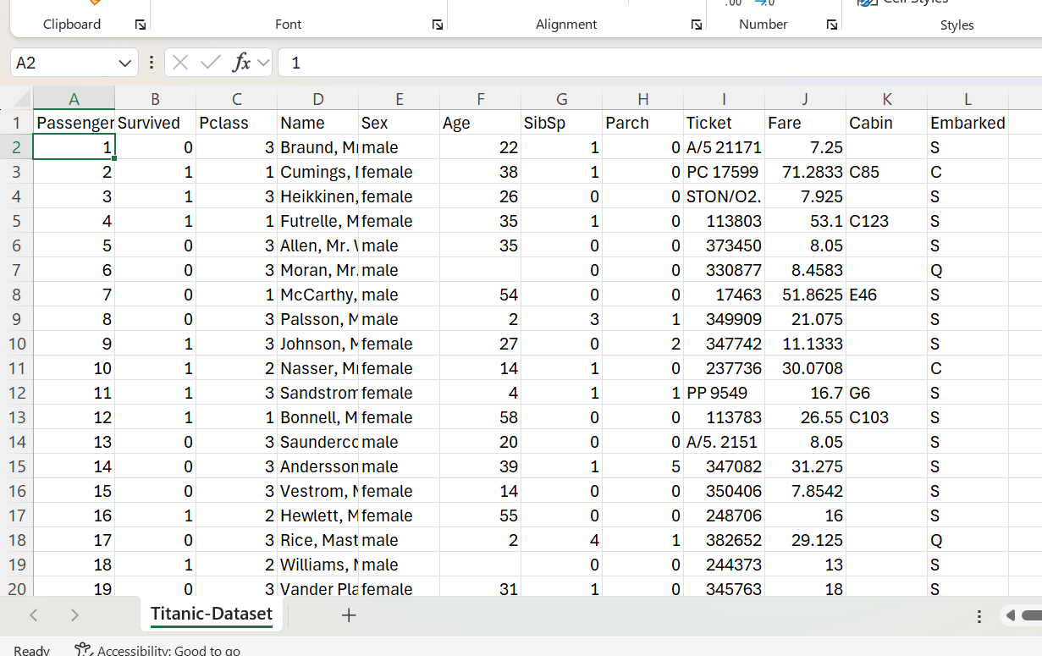

4. TOOLS USED
- Microsoft Excel
- Titanic Dataset (Excel format)
- Microsoft Word (for report)

5. All Tasks

TASK 1: Sorting Data by Age:

Goal
To arrange passengers from youngest to oldest.

Working (What is happening)
Sorting arranges the data in a specific order. When we sort the Age column from smallest to largest, Excel reorganizes all rows so that the youngest passengers appear first and the oldest appear last. All related data (name, class, fare, etc.) moves together correctly.

Screenshots :
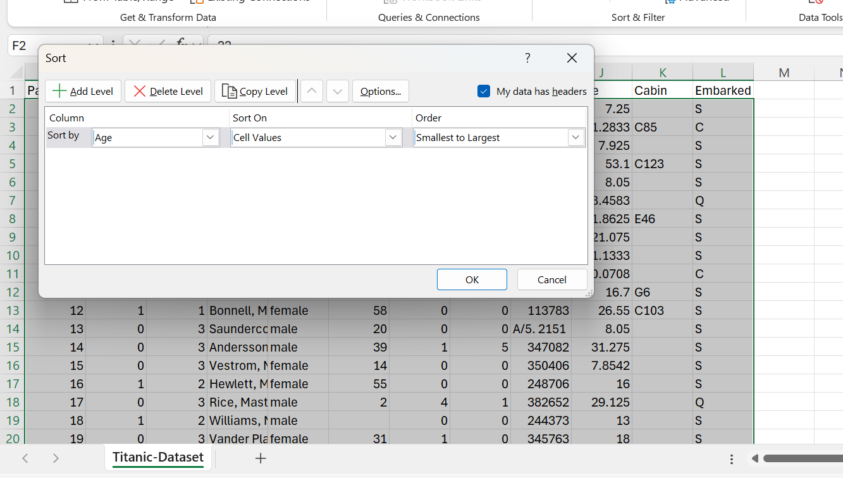

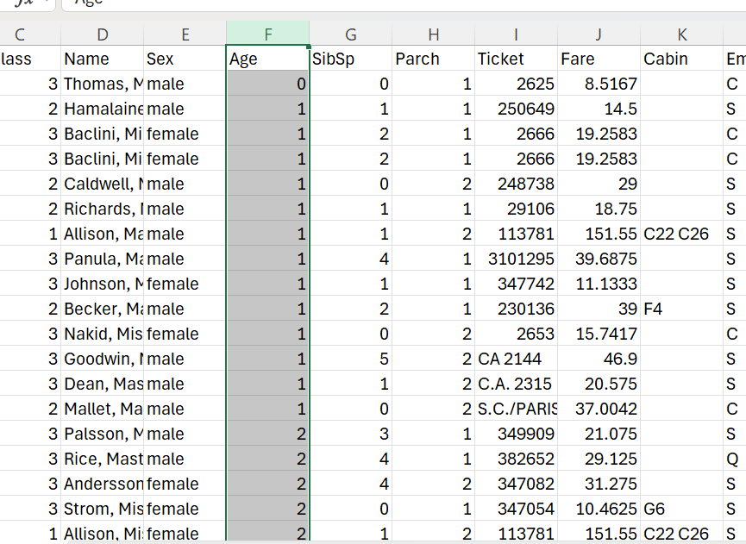

Insights (What we learn)
- We can clearly see the youngest and oldest passengers.
- Age-based patterns become easier to analyze.
- It helps in further analysis such as identifying children and elderly passengers.

TASK 2: Filtering Survivors:

Goal
Display only passengers who survived.

Working
Filtering temporarily hides rows that do not meet a condition. When we apply a filter on the Survived column and select only value 1, Excel displays only passengers who survived the Titanic disaster while hiding non-survivors.

Implementation (Screenshots)
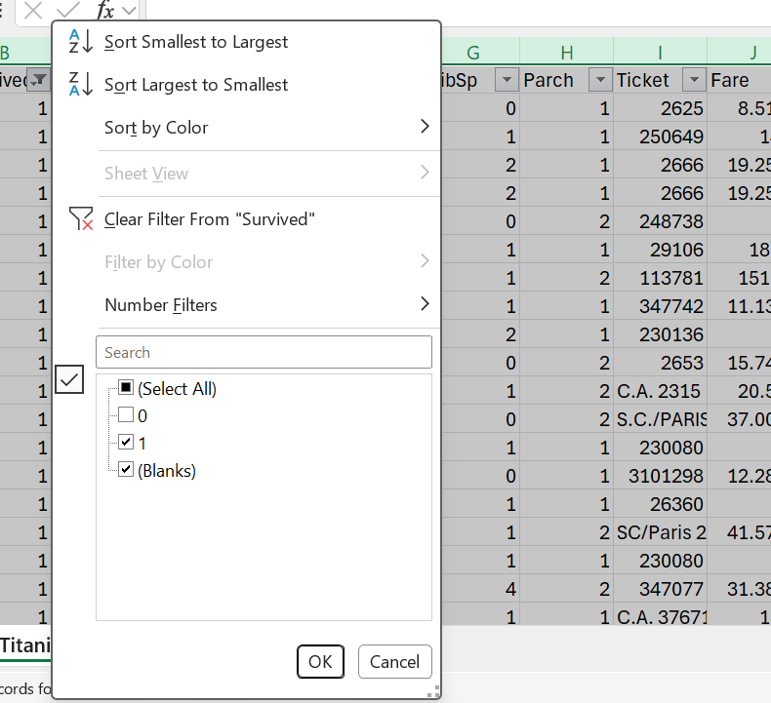
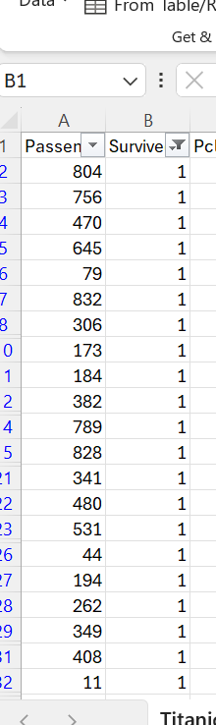

Insights
- Allows focused analysis on survivors only.
- Helps study characteristics (age, gender, class) of people who survived.
- Makes comparisons easier in later tasks.

TASK 3: Conditional Formatting (Children Highlight)

Goal
Highlight passengers under 18 years.

Working
Conditional formatting automatically applies color to cells based on a rule. When we apply the rule Age < 18, Excel highlights all passengers who were children. The data itself does not change—only the visual appearance does.

Implementation

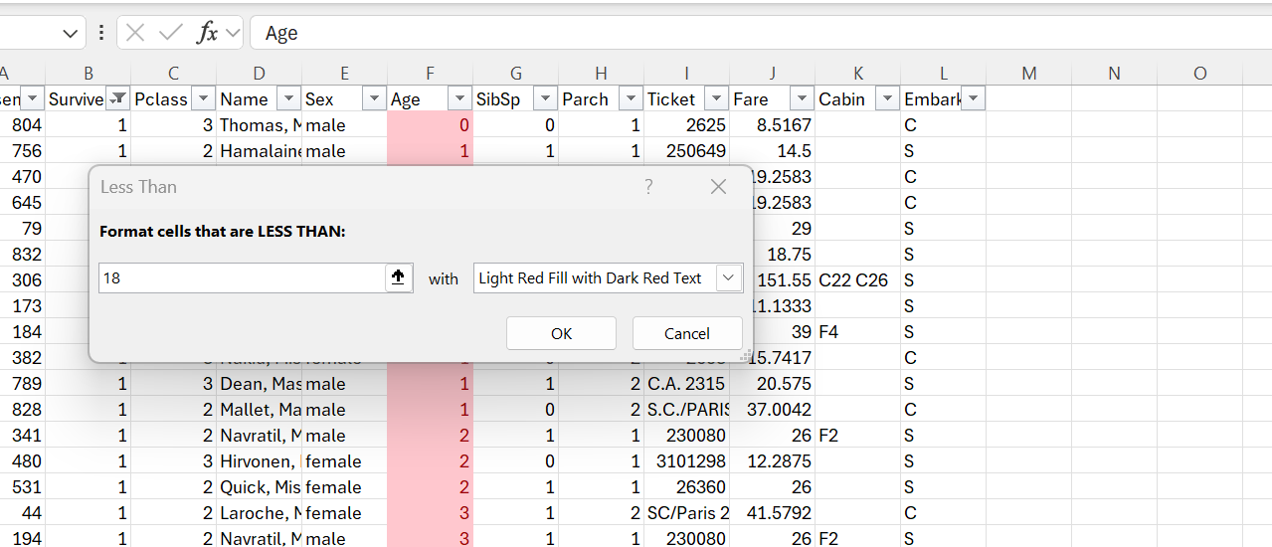

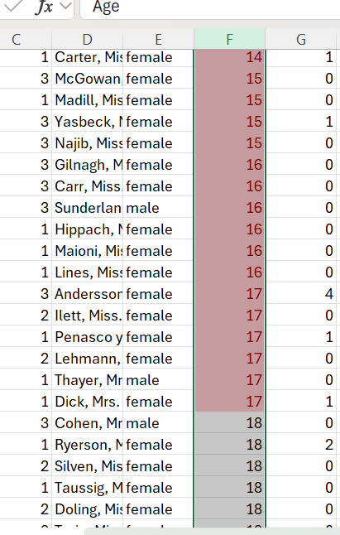

Insights
- Children are instantly visible in the dataset.
- Helps identify whether children had better survival chances.
- Improves readability and quick decision-making.

TASK 4: Bar Chart – Survivors vs Non-Survivors

Goal
Compare number of survivors and non-survivors.

Working
A bar chart compares numerical values visually. Using the COUNTIF function, we count survivors and non-survivors, then represent these counts using vertical bars. The height of each bar represents the number of passengers.

Implementation
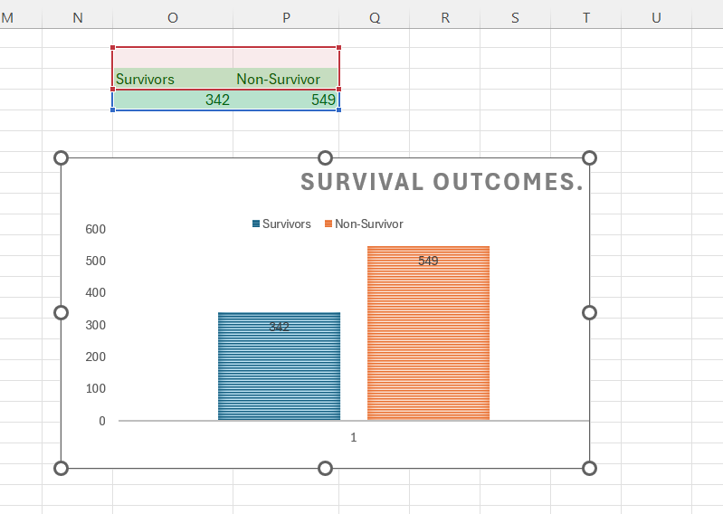
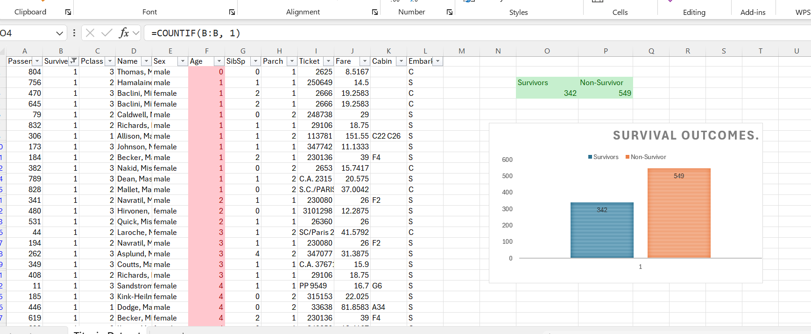

Insights
- Non-survivors are significantly more than survivors.
- Shows the severity of the Titanic disaster.
- Visual comparison is clearer than raw numbers.

TASK 5: Pie Chart – Passenger Class Distribution

Goal
Visualize passenger distribution across classes.

Working
A pie chart shows how a whole is divided into parts. We count passengers in each class (1st, 2nd, 3rd) and display their percentage share using a pie chart.

Implementation
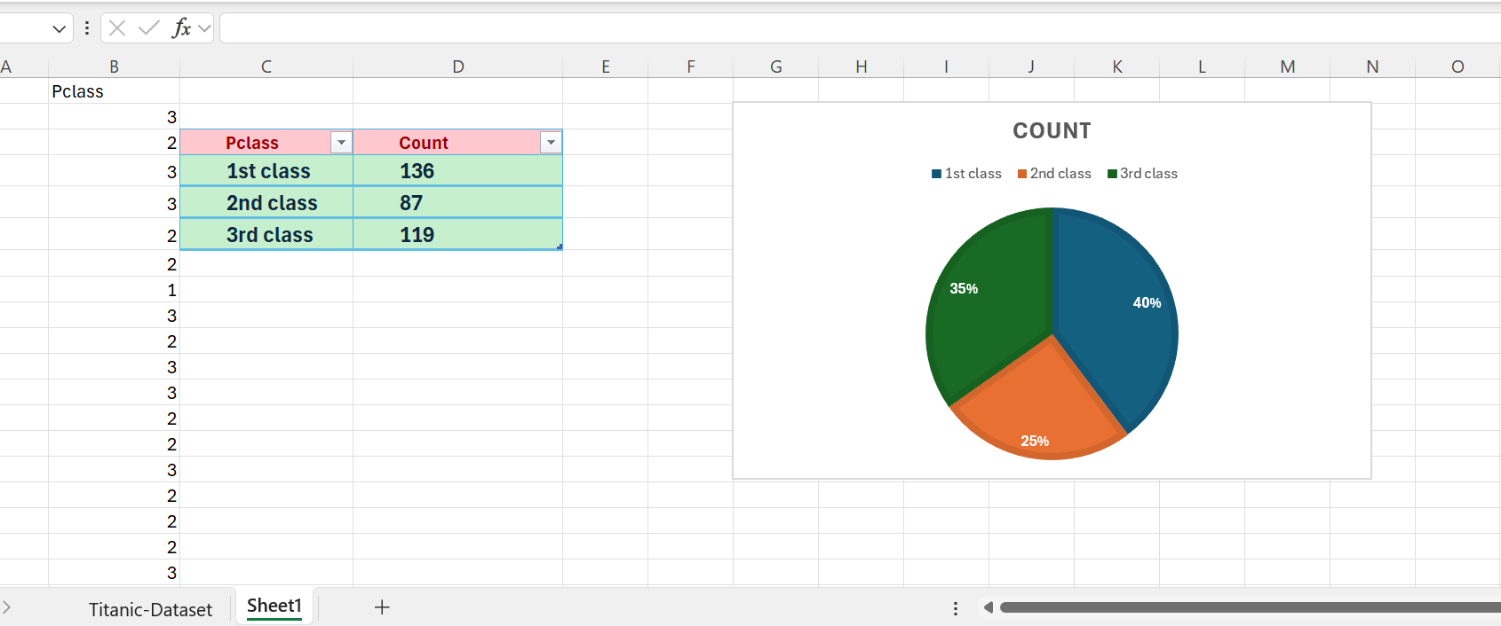

Insight
- Majority of passengers were from 3rd class.
- 1st class had the smallest number of passengers.
- Highlights social and economic distribution onboard.

TASK 6: Histogram – Age Distribution

Goal
Understand age frequency.

Working
A histogram groups continuous data into ranges (bins). When we create a histogram of age with a bin width of 5, Excel groups passengers into age intervals (e.g., 0–5, 6–10, etc.).

Implementation
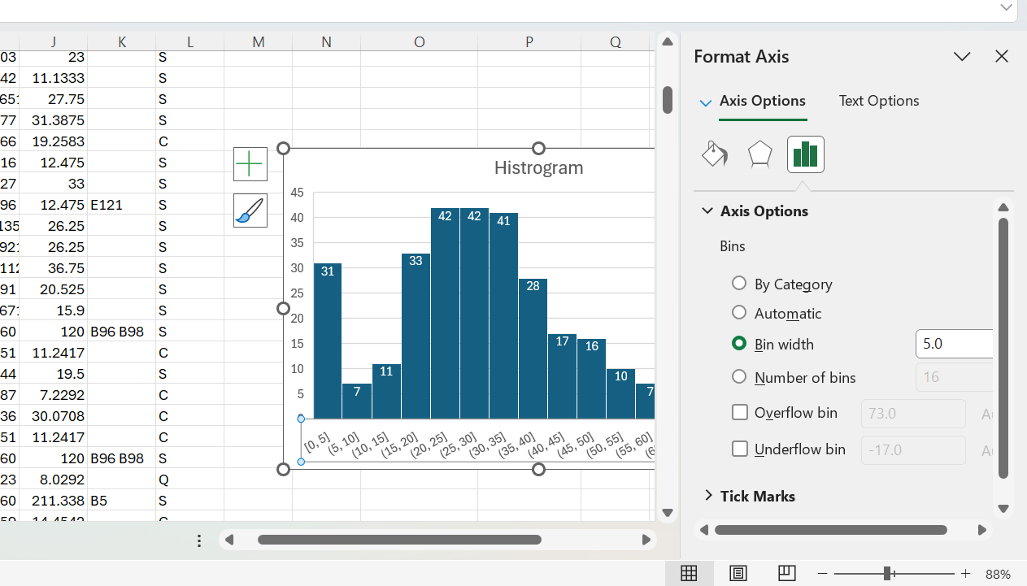
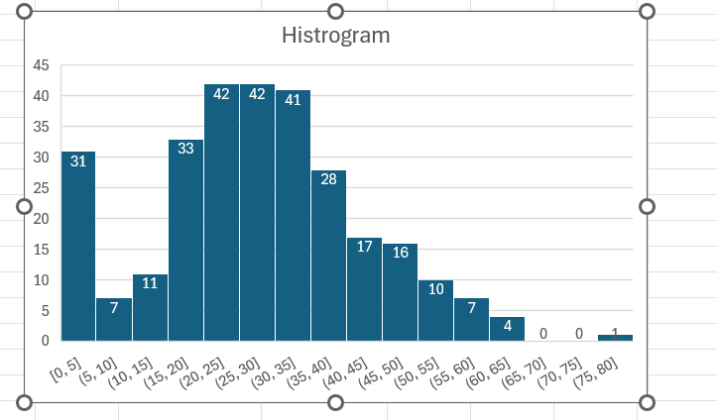

Insights
- Most passengers were between 20–40 years.
- Very few passengers were extremely young or very old.
- Helps understand overall age structure of passengers.

TASK 7: Clustered Bar Chart – Gender Survival

Goal
Compare survival between males and females.

Working
A pivot table groups data automatically. By placing Sex in rows and Survived in columns, Excel calculates survival counts by gender. The clustered bar chart visually compares survival for males and females.

Implementation
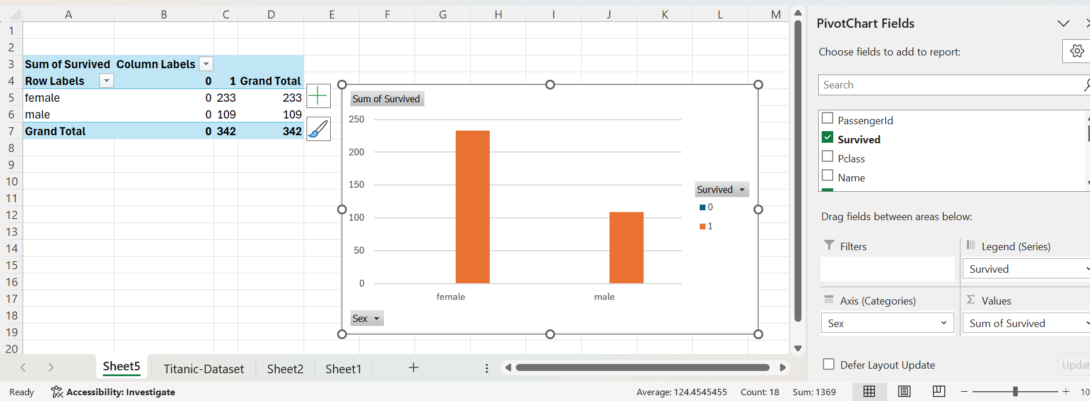

Insight
- Females had a much higher survival rate.
- Confirms “women first” evacuation policy.
- Gender played a major role in survival chances.

TASK 8: Line Chart – Age Groups

Goal
Analyze survival trends by age group.

Working
Age groups are created using an IF formula. Passenger counts in each age group are plotted using a line chart. The line shows changes across age groups.

Implementation

Insight
- Younger age groups show higher survival trends.
- Survival decreases with increasing age.
- Line chart helps identify trends rather than just comparison.

TASK 9: Pivot Table – Average Fare by Class

Goal
Calculate average fare per passenger class.

Working
A pivot table summarizes large data efficiently. By placing Pclass in rows and Fare in values (Average), Excel calculates the average fare paid by passengers in each class.

Implementation

Insight
- 1st class passengers paid the highest fares.
- 3rd class passengers paid the lowest fares.
- Shows economic differences among passenger classes.

TASK 10: Pivot Chart – Average Fare Visualization

Working
A pivot chart is directly linked to a pivot table. When the pivot table data changes, the chart updates automatically. A column chart visually represents average fare by class.

Implementation

Insight
- Clear visual comparison of fares.
- Highlights large fare gap between classes.
- Makes financial differences easy to understand.

